**ServerHump (Admin Panel)**

**Login Page:**

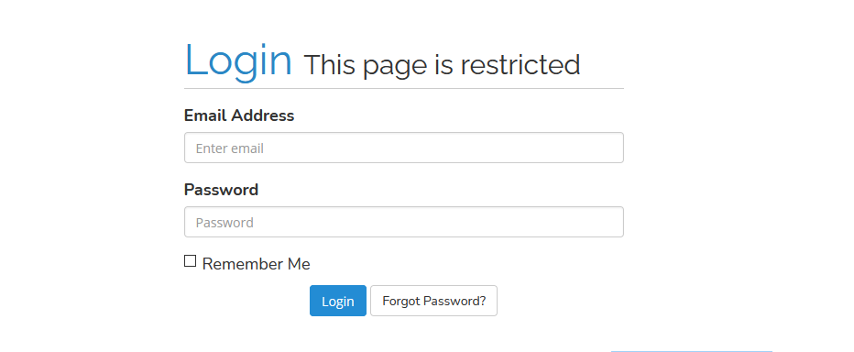

Follow this Look and Feel. We dont need any Image in Background. It need not be exactly like this but it should be some what with this color.

This Login Text Box and Password should be aligned at Right of the page

Example

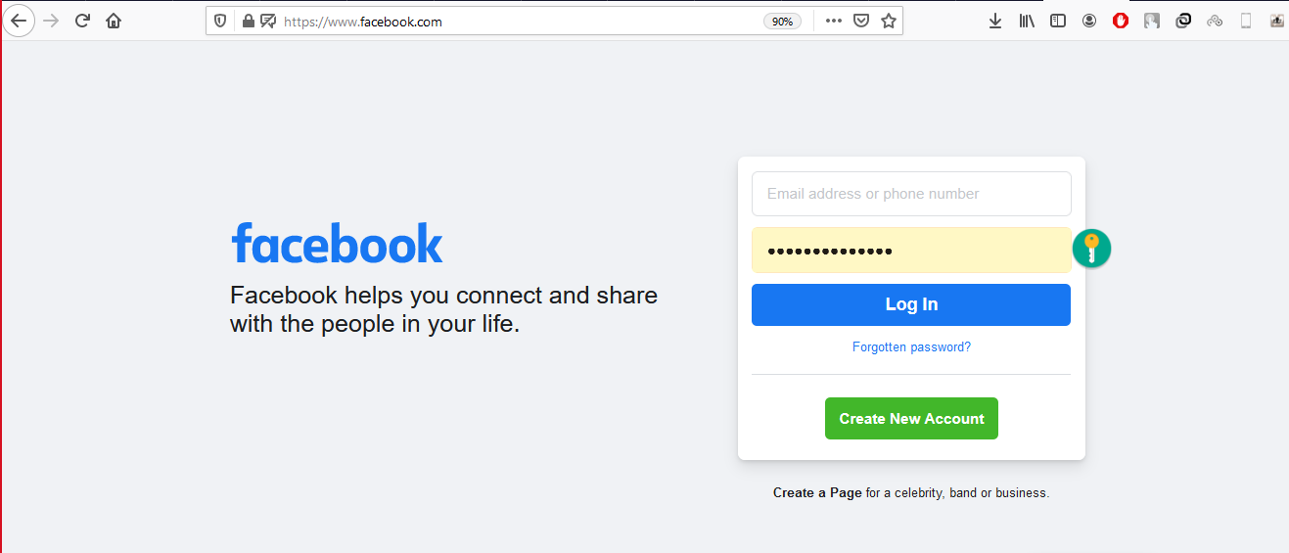

Changes with Current Login Page

Remove the Background

Move it from middle to right

Add Either logo or text or an Image to the Left side. (What Ever on Left Side just Look should be good )

**Sign Up Page**



Same as Login Page just Aligned to Right.

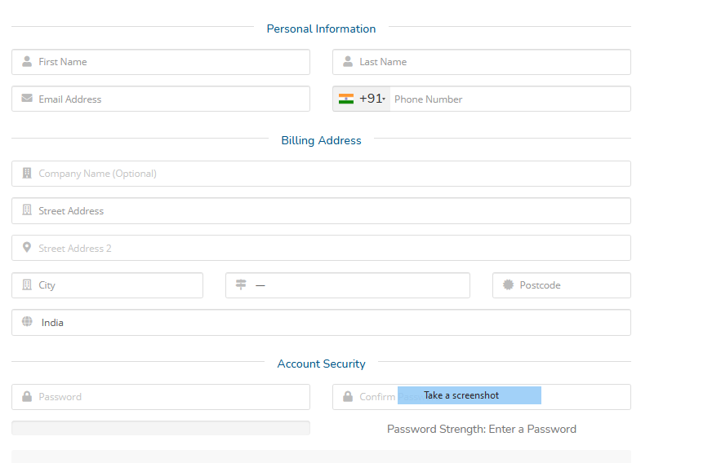

1. Need All this Fields in Sign Up Page Mentioned in above
2. **CAPTCHA**  is needed in SignUp Page.
3. All Fields are Required Except Address line 2
4. Country should be dropdown listing all.
5. State should change based on Country
6. City can be a text box no issues.
7. Regex Expression on Mail and Password (One Cap One Number One Special char min 8 characters)

Sample of above screenshot <https://www.serverhump.com/portal/register.php>

Dashboard.

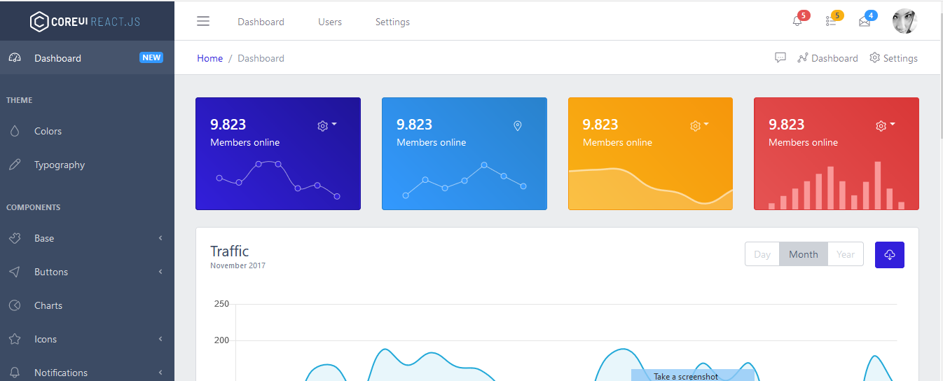

**Changes to Design**

Left Pane may look like mentioned above (NO Image in Background) , and in Home Page counter should be like above one **not extended to the end** reduce the size and keep 3 or 4 counters.

Another example of Counter

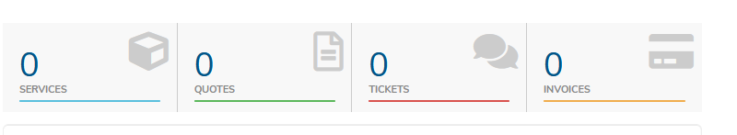

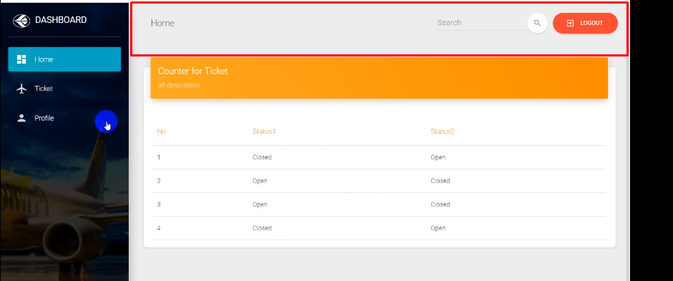

Keep the in top bar background as shown in above the sample dashboard Image.

**PAGENATION IS NEEDED IN GRID VIEW with More than 5 Rows**

**PROFILE PAGE CHANGES:-**

1. Add all the fields which we obtained during signup. In update page
2. Remove the Author on right side and extend it to Edit Profile to END.
3. Make sure all the fields are required and REGEX is there in those fields.(Same Validation as in Signup Page)

**Ticket or Support Page**

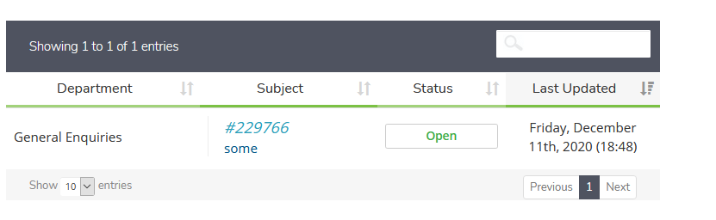

**BUG with Ticketing System:-**

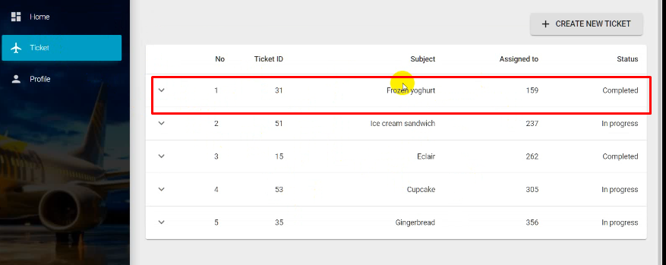

**Missing Reply**

**Every Ticket can be replied,**

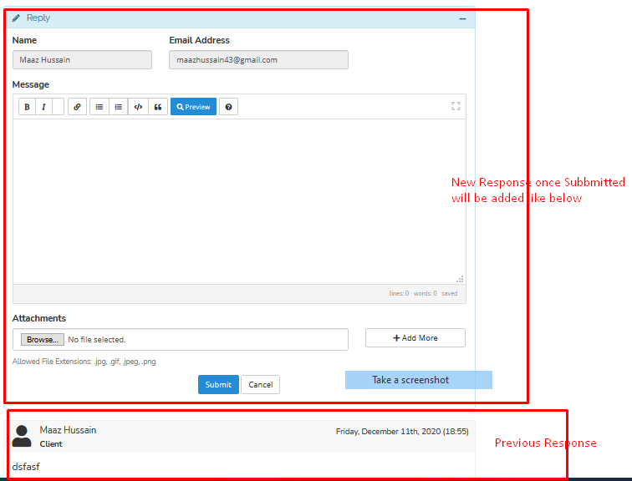

Every Ticket Reply can look This

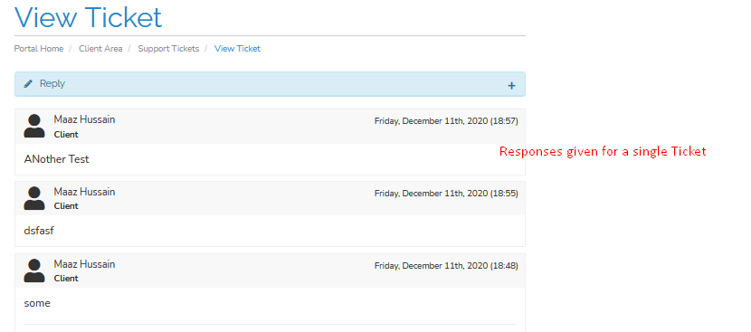

Issues with Ticket System

1. Reply System Is Missing
2. Attachment during Ticket Creation is missing
3. Add one more drop down for Status Open, InProgress Closed
4. Increase the Width
5. Not sure in Video Hoping it to be responsive :-)

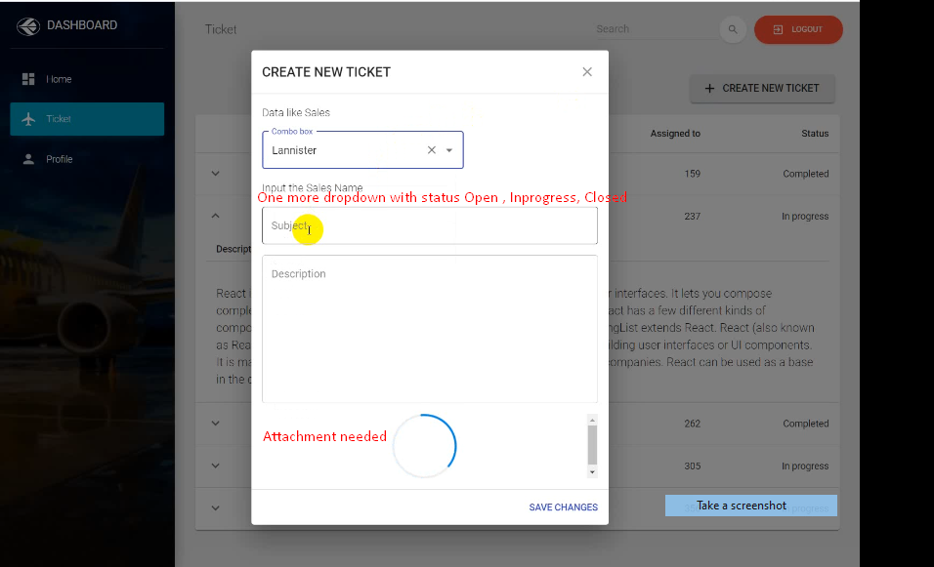

New Feature, Missed in Requirement.

On Left Side of the pane there will be Another Link Called **Hosting** with 2 sub menu **View Accounts and Create a Account**

**Create Account click on Sub Menu will display below page**

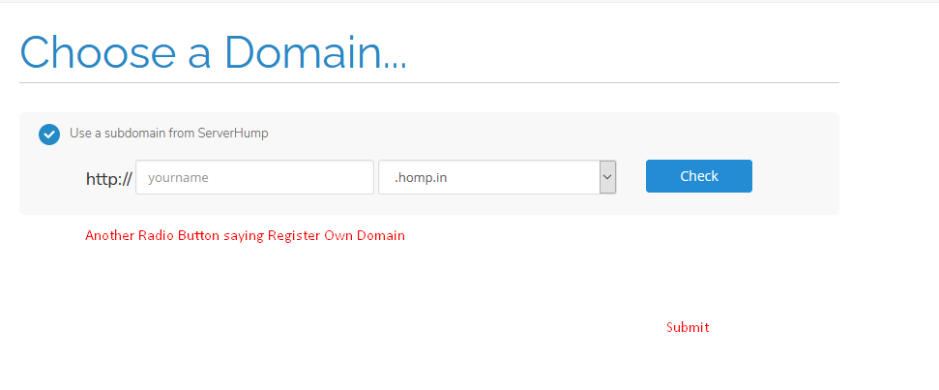

On Clicking Submit Console Log the User Selection Same on Clicking Check Console Log the User Selection.

**View Accounts**

**On clicking View Account it should Show List of Account**

**Also a Create New button should be there when Clicking on it should take to above Create Account page.**

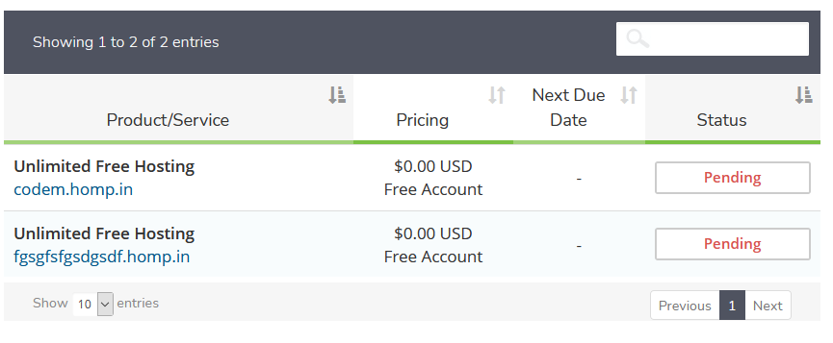

**On clicking on any of the above listed account**

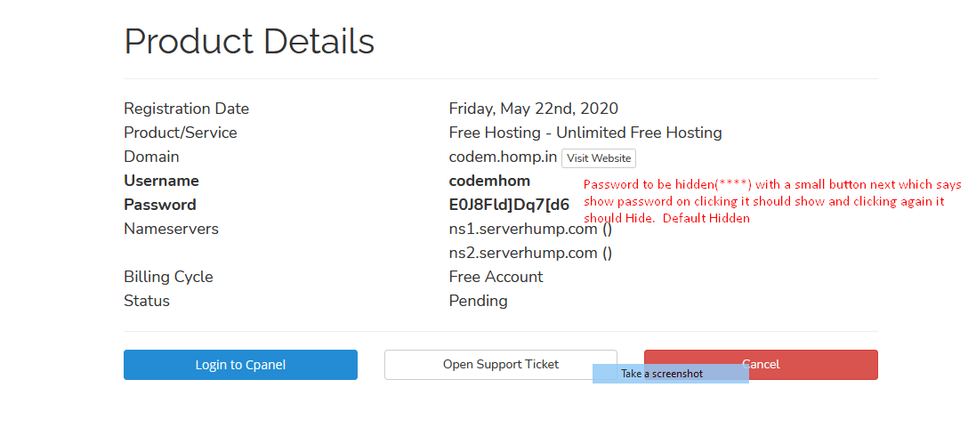

**On Clicking on any button Console Log the data which is shown in the page.(Will be useful when we make an API call)**

**Points to be Noted**

**Login and SignUp**

* Login and signup page should be aligned Right as shown in the above example Facebook. (No Background Images)
* In Signup Page All Fields are required except Address line2 and keep proper validation for email, password and confirm password

**Dashboard**

* In Home Page Display Counter as mentioned above, 2 or more counter. Values be like Number of Tickets and Number of Hosting Account.
* Follow the screen shot and remove background image in left navigation and give some background on Top Nav. As mentioned in above sample dashboard Mockup
* Make sure user can reply to that ticket and all the previous replies should come when we click on the existing ticket

**Fonts**

1. For Action clike Create or Update use Primary Button Blue
2. For Action like Delete Logout use Primary Button RED
3. Remove Green color from profile Update